|  |
| --- |
| Photo displaying partial image of two pie charts on a canvas-textured page |
| Data Migration Plan Documentation  By 1905may28Hadoop |
| |  |  |  | | --- | --- | --- | |  | [Date] | [Course title] | |

Table of Contents

**Type chapter title (level 1)1**

Type chapter title (level 2)2

Type chapter title (level 3)3

**Type chapter title (level 1)4**

Type chapter title (level 2)5

Type chapter title (level 3)6

# Introduction

This document is designed to be a single collection of information to inform future development teams on the progress made during this project. The main purpose of this project is to migrate from Caliber v.1 to Caliber v.2.

## Caliber v.1

Caliber v.1 is a performance management suite developed to collect and analyze evaluation of Revature trainees. Caliber receives input from several metrics systems throughout the lifecycle of the associate, and compiles those metrics into some readable format for further analysis.

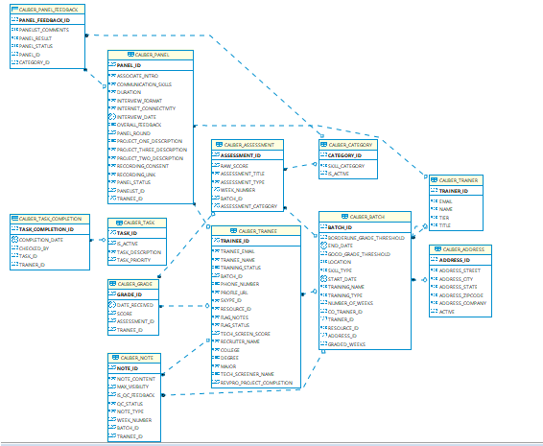

Figure Caliber 1 Schema

# Appendix A